EX.N0:7 | Implement program for decomposingtime series data into trend and seasonality
DATE:07/04/2025

AIM:
To Implement program for decomposing time series data into trend and seasonality.

PROGRAM:

import pandas as pd

import matplotlib.pyplot as plt

from statsmodels.tsa.seasonal import seasonal_decompose

# Load the dataset

file_path = r"/content/MSFT.csv"

df = pd.read_csv(file_path, parse_dates=['Date'], index_col='Date')

df.columns = df.columns.str.strip()

print("\nAvailable columns:", df.columns)

# Specify the target column for decomposition

target_col = "Adj Close"

if target_col not in df.columns:

raise ValueError(f"'{target_col}' column not found in the dataset.")

# Extract the target time series and remove any missing values

ts = df[target_col].dropna()

# Perform seasonal decomposition

result = seasonal_decompose(ts, model='additive', period=30)

# Plot the decomposed components

plt.figure(figsize=(12, 10))

plt.subplot(411)

plt.plot(ts, label="Original", color='blue')

plt.title("Original Time Series")

plt.legend()

plt.subplot(412)

plt.plot(result.trend, label="Trend", color='orange')

plt.title("Trend Component")

plt.legend()

plt.subplot(413)

plt.plot(result.seasonal, label="Seasonality", color='green')

plt.title("Seasonal Component")

plt.legend()

plt.subplot(414)

plt.plot(result.resid, label="Residuals", color='red')

plt.title("Residual Component")

plt.legend()

# Adjust layout and display the plot

plt.tight_layout()

plt.show()

OUTPUT:

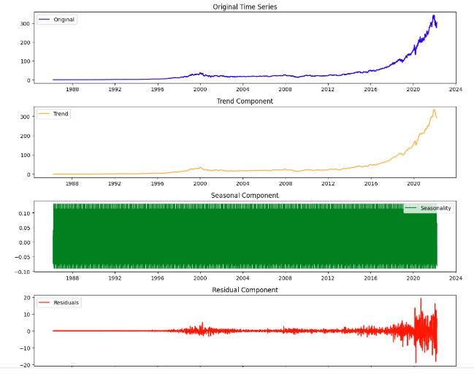

RESULT:

Thus, the program for Implement program for decomposing time series data into trend and seasonality is executed successfully.

